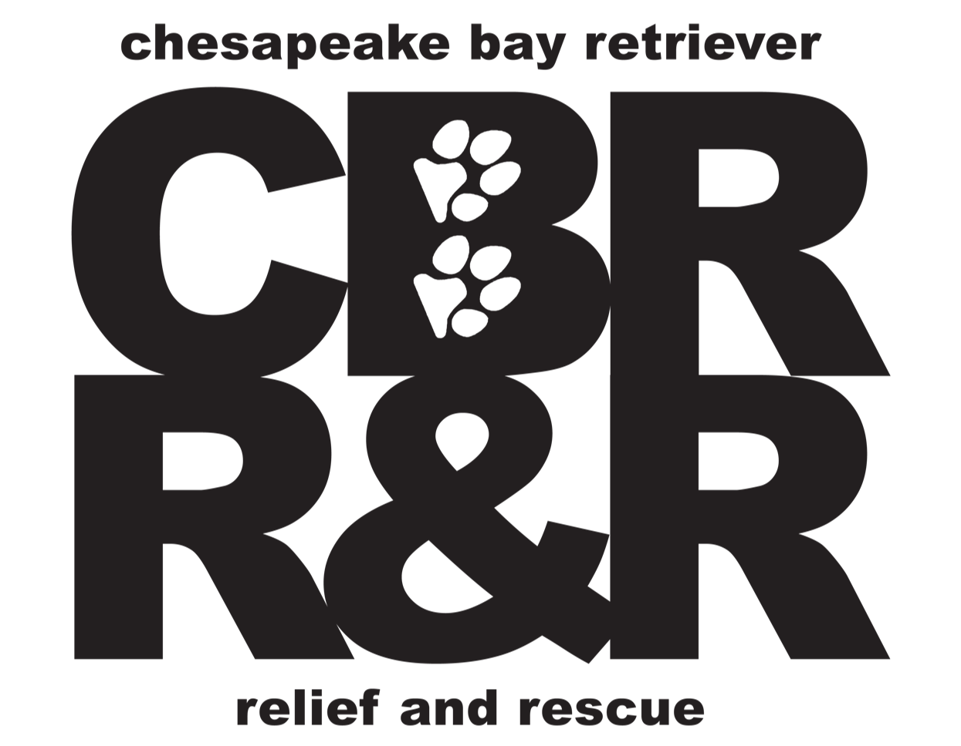

Transport Guidelines

- Read the bio about the dog before transporting. Get as much information as you can.
- Bring supplies: water, bowl, blanket, towels, wipes, plastic bag and maybe a stuffed animal to make the dog feel secure.
- Leave your own animals at home. Check with the Regional Director for permission to bring your pet beforehand.
- Make sure you leave with paperwork: shelter/owner release forms if not completed electronically & other vet, vaccine, registration papers if available.
- Stow all food and other items sent with the dog, out of sight in case dog guards. Be sure to pass items on to the next transport person.
- Identification of dog be sure dog has collar & tag with mobile contact info.
- Double Leash: while loading or unloading a dog into car, kennel & at pit stops. one clip on lead and a slip-on lead
- In the crate: keep a leash on and if needed you can close the end of the leash in the car door to keep the dog secure.
- Secure and Safe Vehicles: Doors, windows and canopy hatches should be closed and secure, and have effective climate control and ventilation.
- Stops: at least once every four hours to check on dogs, feed, water and clean as necessary. Hang on tight in case the dog tries to bolt.
- Never leave animals unattended in a parked vehicle.
- Please notify us once transport duty is completed.
- Questions or Problems? Call if you have any concerns along the way.
- Take precautions: When you arrive home after transport, take precautions to not expose any transmissible disease or fleas to your own pet.

**Always pay attention to the dog when he is out of your vehicle. This means no cell phone use or any other kind of inattention when a dog is not secured in your vehicle. **

Walk the dog outside before transport if you can so that the dog can stretch his legs, eliminate, and sniff freedom before you put him back into a crate.

Dogs can be hyper, stressed, nervous and anxious and may cry with nervousness, or keen with sadness upon separation. Talk firmly and gently so he learns your voice and hears that it will be okay.

Remember this dog doesn't know you, so you may not be able to grab a collar or pick it up to load into the vehicle. Slip leads are much easier and safer to use when trying to catch a dog that is head shy. Always have a slip lead within reach, just in case.

Enjoy your trip and remember how important this journey is for the dog.

