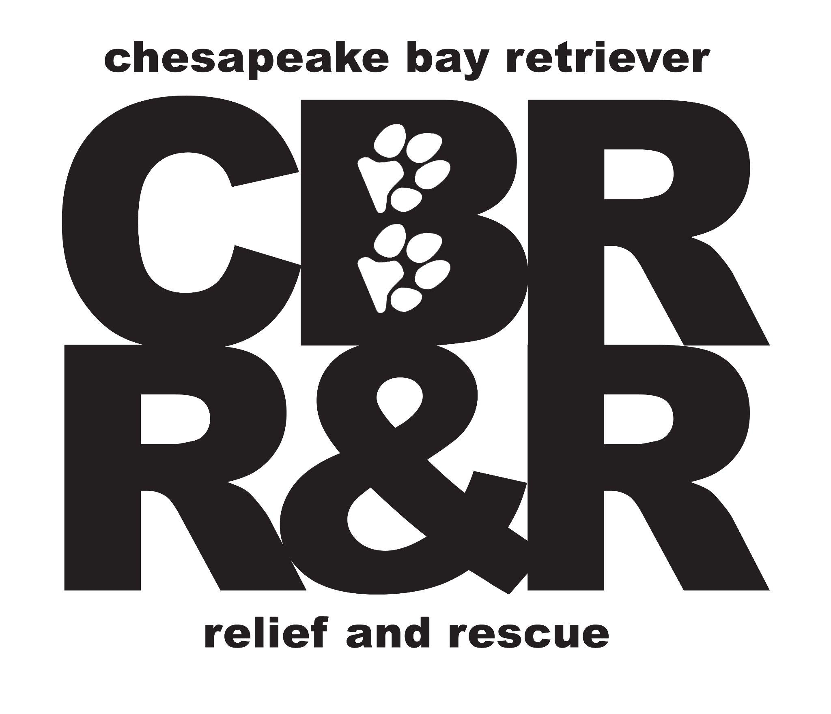
Canine Behavior Evaluation
Dog Name:_____________________________
Evaluator:______________________________ Observer/Scribe:_____________________________
Date________________________
Age: _____ Date of Birth: _______________ Sex: ________ Neutered/Spayed? _______
Weight: ____ Purebred?________ Color: ______________ Breeder:_________________
Has breeder been notified? Yes___ No___
Owners Name: ___________________________________________________________
Address: ________________________________________________________________
Health
Veterinarian: ____________________________________________________________
Shots Up to Date? ___________________ Heartworm Preventative? ________________
Medical Problems? ________________________________________________________
briefly describe the dog's physical condition: ___________________________________
Feeding Schedule & Brand: _________________________________________________
________________________________________________________________________
Dogs housing
Where does dog stay during the day?_________________________________________
Nights? _________________________________________________________________
Housebroken? ___________________________ Crate Trained? ____________________
Regular contact with children? ________________ Ages: _________________________
Other dogs_______________________________________ Cats:___________________
Behaviors
What type of collar does/did dog normally wear? _______________________________
Walk with dog on leash: Yes___ No___ Does the dog pull on leash? Yes___ No___
Describe his behavior on leash: ______________________________________________
Separation Anxiety: _______________________________________________________
Do we know if dog has food anxiety or toy possession? ___________________________ ________________________________________________________________________
Will the dog play fetch with you? ________ how excited is s/he for a toy? ___________
Does he bring the toy to you? Yes___ No___ Will he release a toy to you? ___________
Reaction to male dogs:
Does dog show: loves ___interest___ tolerance___ play___ fear___ aggression___
Reaction to female dogs:
Does dog show: loves ___ interest___ tolerance___ play___ fear___ aggression___
Can you touch the dog's muzzle? Yes___ No___ Paws? Yes___ No___
Touch dog's body elsewhere? Yes___ No___
Dog's car behavior: ________________________________________________________________________
Activity level: ________________________________________________________________________
Frequency and how exercised: ________________________________________________________________________
Personality: very shy___ reserved___ normal___ confident___ other________________
Briefly describe personality: ________________________________________________________________________
Aggressive with people at all? ________________________________________________________________________
Owner's reason for placement: ________________________________________________________________________
Evaluator's name and phone number: ________________________________________________________________________
Best time to call you about this dog: ________________________________________________________________________
Shelter Information
Intake Location: __________________________________________________________________
Approximate Arrival Date: __________ Actual Arrival Date: _________________
Owner release form signed?________________________________________________

Cage Presentation Test – while dog is still in kennel:
1. Stand quietly in front of the kennel, turned side-ways, look straight ahead, not at the dog. Watch out of the corner of your eye for 5 seconds.
- stands quietly in cage, calmly looking at tester
- comes towards front of cage in a calm solicitous manner (loose relaxed body)
- stays in the back of the kennel run – shaking, low growl, whale eye (circle all that apply)
- moves away, towards the back of run – shaking, low growl, whale eye (circle all that apply)
- charges at the front of the cage in a threatening manner (barking, snarling, growling)
2. Turn and face the dog and look directly into his eyes for 5 seconds – DO NOT threaten dog remains calm with relaxed body postures (low wagging tail, soft eyes)
- Displays avoidance behaviors (turns head sideways, divert eyes)
- Displays submissive or fearful body postures (ears back, tail down, body low, backing up)
- displays defensive aggression (growling, barking, baring teeth – while moving away)
- displays offensive aggression (growling, barking, baring teeth – while lunging away)
3. Turn sideways, bend down and talk to the dog in a friendly, solicitous tone of voice for 5 seconds.
- stands quietly looking at you
- comes forward and solicits more interaction
- stays in the back of cage, submissive or frightened (ears back, tail tucked)
- displays defensive aggression (barking, growling, snarling) – circle all that apply
- displays offensive aggression (barking, growling, snarling) – circle all that apply
Sociability Test – Take the dog to the evaluation room
1. Holding the end of the leash – stand and totally ignore the dog for 60 seconds
- ____ dog made social contact lasting more than 2 seconds How many times?_______
- ____ dog made contact less than 2 seconds at a time (drive bys)
- ____ dog completely ignored you and continued to investigate the environment
2. Stroke the dog from neck to back slowly – repeat 3 times waiting 5 seconds between strokes dog moved closer after 1st 2nd 3rd stroke (circle all that apply) and solicited more
- ____ dog moved closer after 1st 2nd 3rd stroke (circle all that apply) and stays next to you
- ____ dog stayed in the same position after 1st 2nd 3rd stroke (circle all that apply)
- ____ dog moved away after 1st 2nd 3rd stroke (circle all that apply) shake off?
- ____ dog completely ignored you and continued to investigate the environment
3. Sit down and ignore the dog for 5 seconds
- ____ dog came over to you within 5 seconds & stayed with you the whole time
- ____ dog came over to you within 5 seconds but then moved away
- ____ dog ignored you – did not come over
4. Remain sitting and talk solicitously to the dog for a full 20 seconds
- ____ dog came over within 1 second and stayed the entire 20 seconds
- ____ dog came over within 1 second but then moved away – did this repeatedly
- ____ dog came over within 1 second but then moved away & never came back
- ____ dog completely ignored you – never came over
With the slip lead on the dog, carefully proceed to the handling portion of the test. Try to act like a typical owner while handling the dog, not a skilled dog professional. Watch the dog closely and be ready to react to any aggression. STOP the test if the dog attempts to bite you or you feel that you are in danger of being bitten.
*If the dog showed no sociability during the sociability test – skip the handling portion and proceed to the resource guarding tests. You can come back to the handling if you see no resource guarding behavior.
Teeth Exam – Stand next to the dog holding the leash in one hand. With the other hand, lift the dog’s upper lips and hold them in that position for 5 seconds. Attempt to repeat this action 5 times in a row. Do not force the dog to accept this – release if he begins to struggle.
____ allows teeth to be looked at 5 times without struggle
____ struggles slightly but allows all 5 exams
____ struggles during 1 2 3 4 5 but settles with the remaining 1 2 3 4 5 (circle appropriately)
____ struggles more with each exam but allows all
____ struggles fiercely and does not allow a single exam
____ tries to push you away with muzzle, jumps at you, barks at you (circle all that apply) ____ displays signs of uneasiness – stiffens, whale eye, low growl (circle all that apply)
____ whips head around towards your hand in a threatening manner
____ growls, snarls, snaps, or bites (circle all that apply)
Handling Test – Use the following scale to rate the dog’s reaction to each handling exercise (record #) *a 3 or a 4 during any handling exercise results in a failure of the handling test.
- Remains calm, allows handling
- Uncomfortable with handling; tenses up, turns had towards hand, resists by pulling away
- freezes, stiffens, whips around towards your hand, gives whale eye (indicate response)
- growls, snarls, snaps, tries to bite (indicate response)
# Response
- a. stand perpendicular to the dog and stroke his far side ______________________________
- b. run hand down his back let and pick up hind foot ______ __________________________
- c. run hand down dog’s tail and tug slightly ______ __________________________
- d. touch and look inside both ears ______ __________________________
- e. wipe body with towel ______ __________________________
- f. tug slightly on the collar ______ __________________________
- g. apply slight pressure to the dog’s shoulders ______ __________________________
- h. hug the dog ______ __________________________
Arousal Test – initiate play with the dog (toys, balls, tug-o-war with rope toy) for 30 seconds and then stop.
- ____ nice level of play
- ____ became fearful and moves away
- ____ did not show any interest in playing
- ____ became highly aroused but calmed down quickly once played ended
- ____ became highly aroused (hyper, intense focus, growling while tugging toy fiercely) stayed that way after you stopped
Food Bowl Test – Give the dog a bowl of food. Once he is eating, use the assess-a-hand to first pet his back, then reach toward the bowl. Nudge his face a little and try to take the bowl away. Repeat this three times.
- ____ stopped eating and backed away from the dish
- ____ continued to eat but did not show any signs of uneasiness
- ____ moved muzzle deeper into the dish and ate faster – intense about food
- ____ stiffened slightly or moved muzzle toward hand (circle response)
- ____ froze, gave whale eye, snarled (circle response)
- ____ growled, lunged, snapped at, or bit hand (circle response)
- ____ no interest in food – TEST AGAIN LATER
Possession Test – Give the dog a rawhide, pig ear, or piece of trash (empty hotdog wrapper, etc.). Once the dog has taken possession of the item. say “drop it” and then reach for the item using the hand – attempting to take away the item.
- ____ readily dropped item upon request
- ____ allowed assess-a-hand or real hand to take object away (circle one)
- ____ resisted letting go of possession but did not show outward aggression
- ____ froze, gave whale eye, snarled (circle response)
- ____ growled, lunged, snapped at, or bit hand (circle response)
- ____ showed no interest in any item – TEST AGAIN LATER
Stranger Test – Someone knocks on the door – you say, “who’s there? Come in!” Stranger then enters, stops at least 6 feet away and stares at the dog for 3 seconds; then takes two steps forward, stops, and reaches towards the dog. Stranger then squats down, facing sideways, and talks to the dog in a friendly voice.
- ____ dog remains calm, and is friendly upon solicitation
- ____ dog is nervous about stranger (ears back, tail tucked), is friendly upon solicitation
- ____ dog alarm barks or growls and backs off completely, is friendly upon solicitation
- ____ dog alarm barks, hackles up, growls, doesn’t calm readily, eventually is friendly upon solicitation but in a cautious way.
- ____ dog alarm barks, hackles up, growls can’t settle, will not approach upon solicitation
- ____ dog alarm barks, hackles up, growls, snarls, lunges – not safe to allow approach

Dog-to-Dog Test – Take the dog being tested outside and bring a previously tested dog out (both dogs leashed). Repeat tests with several dogs.
Upon seeing the other dog:
#1 #2 #3
____ ____ ____ remains calm – with or without interest in the other dog (circle one)
____ ____ ____ pulls forward to get closer to the other dog but body language remains friendly or neutral
____ ____ ____ reacts with threats (barking, lunging, snarling, growling)
Bring dogs to each other and allow interaction. Be ready to separate at first signs of serious aggression(snarling, growling, lunging, snapping)
#1 #2 #3
____ ____ ____ totally ignored other dog
____ ____ ____ relaxed and friendly with other dog
____ ____ ____ invited play (play bow, pawing, friendly barks or whines, etc.) (circle all that apply)
____ ____ ____ displayed submissive behaviors (lowered body, tail tucked, ears down, rolled over) (circle all that apply)
____ ____ ____ displayed dominant behaviors (placing head or paw on other dog’s back, mounting)
____ ____ ____ displayed defensively aggressive behavior (bared teeth, growling, lunging) (circle)
____ ____ ____ displayed offensive aggressive behavior (bared teeth, growling, lunging)(circle)
***Failed responses for each component test appear in italics
Number of failed components: ___________
Additional Comments:
Recommendation:_____________________________________________________________

